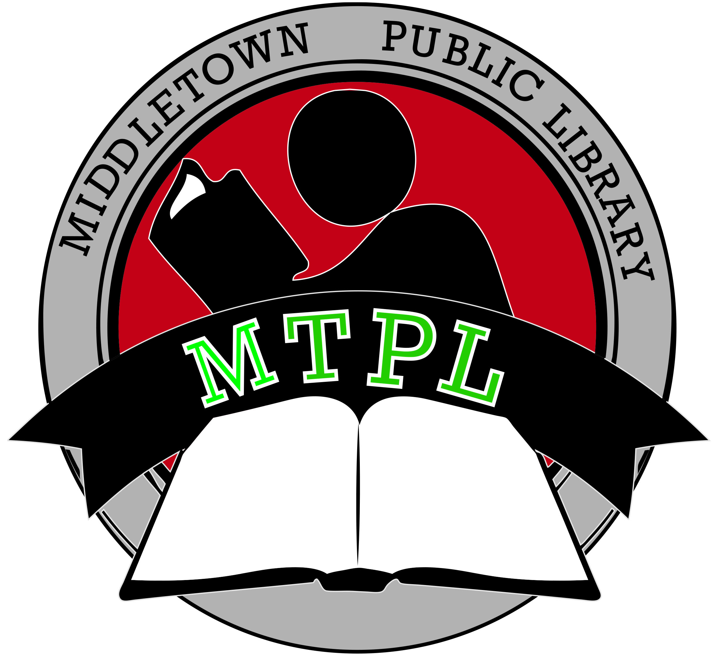
MIDDLETOWN TOWNSHIP PUBLIC LIBRARY
55 New Monmouth Road, Middletown, NJ 07748
Phone: 732-671-3700 • Fax: 732-671-5839
www.mtpl.org

BOOKS IN SHOOLS PROGRAM
MEMO OF AGREEMENT

_______________________________ (Name of School) agrees to be financially responsible to the Middletown Township Public Library for any lost or damaged materials charged to the_____________________________(Name of School) barcoded library card.

_____________________________________ Print or Type Name of Principal

_____________________________________ Signature of Principal

______________________________________
Date

Name of Reading Specialist________________________________________________________
School Address______________________________________________________________________________
Phone Number________________________________________________________________________
Email address_________________________________________________________________________
Please return to Kate Hammond, khammond@mtpl.org

